Hello Gentlemen we have just mapped the rapidPro API for CHAT Delivery.

Please see the results of our test.

#Send Message from rapidPro API

Attach Screenshot Below

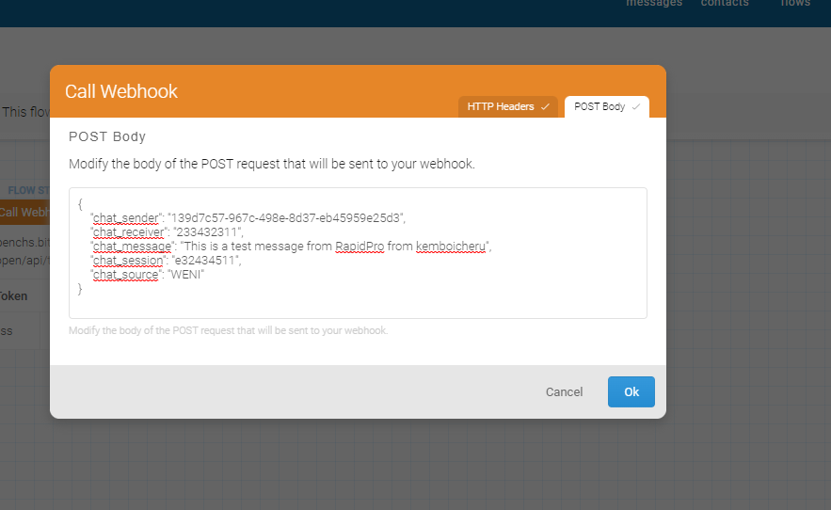

#Receive message from rapidPro at the Helpline on the test environment.

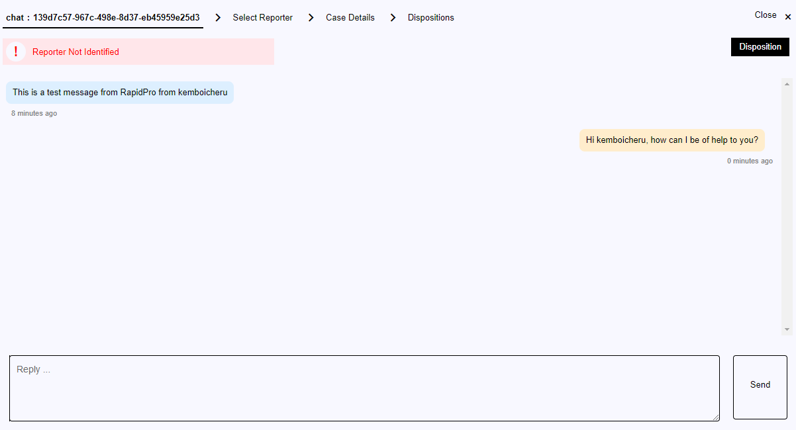

#view message on rapidPro interface

